Lab Exercise 20
Creating a Pipeline Script

Objective: To create a pipeline script for automating build processes in Jenkins

Tools required: Jenkins

Prerequisites: None

Steps to be followed:
- Log in to the Jenkins CI tool and create a pipeline script

Step 1: Log in to the Jenkins Cl tool and create a pipeline script

- Open the browser, go to the Jenkins Dashboard by typing localhost:8080 in your browser, provide the credentials, and click the Sign in button


Note: The credentials for accessing Jenkins in the lab are Username: admin and Password: admin.

- Click on the New Item option as shown in the screenshot below:

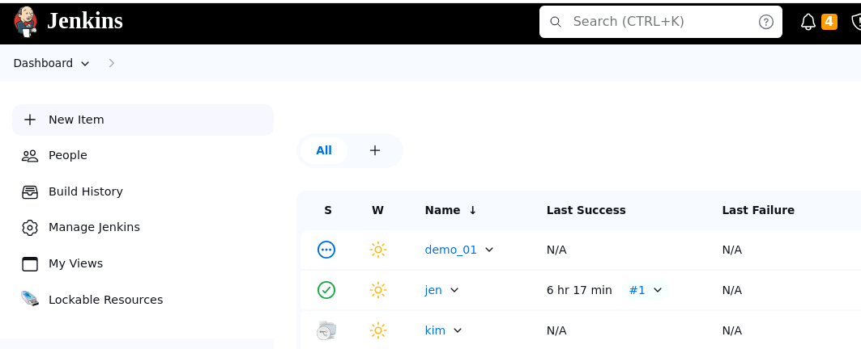

OUTPUT :-
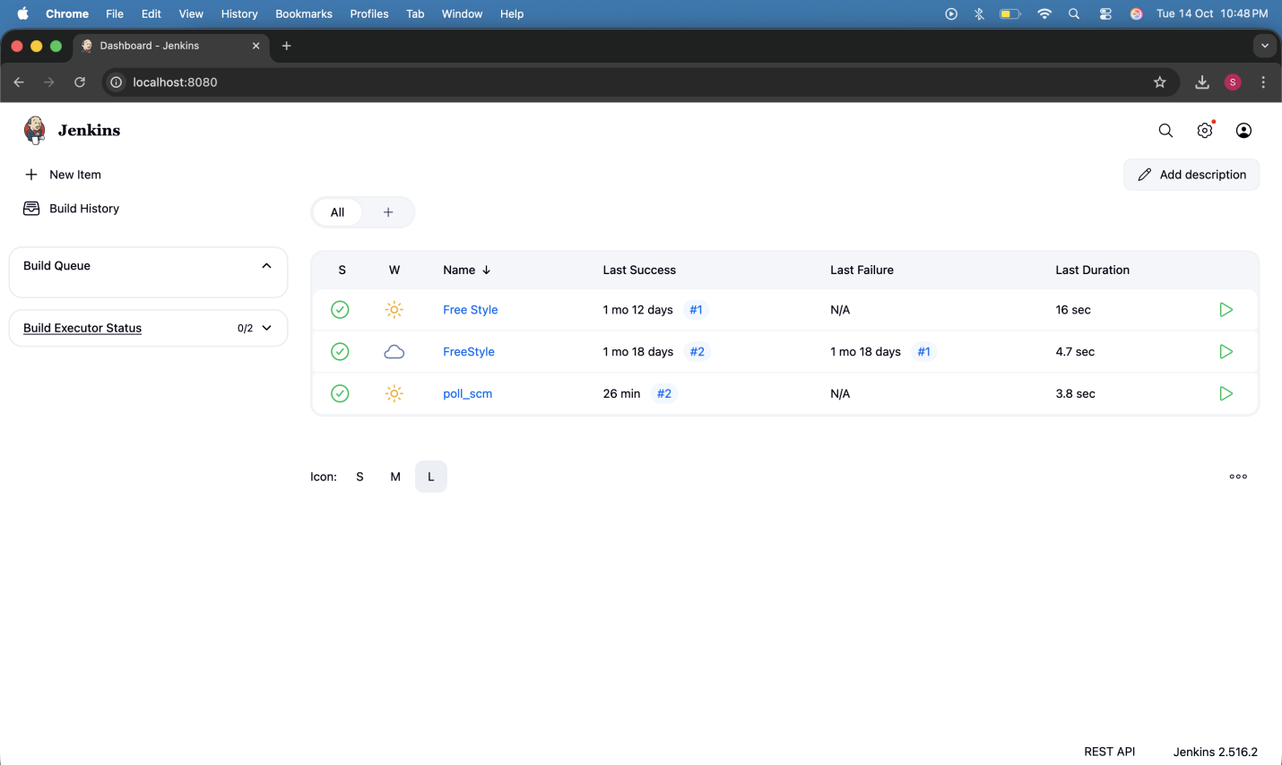

- Enter a desired name for the project, select Pipeline, and then click on OK as shown in the screenshot below:

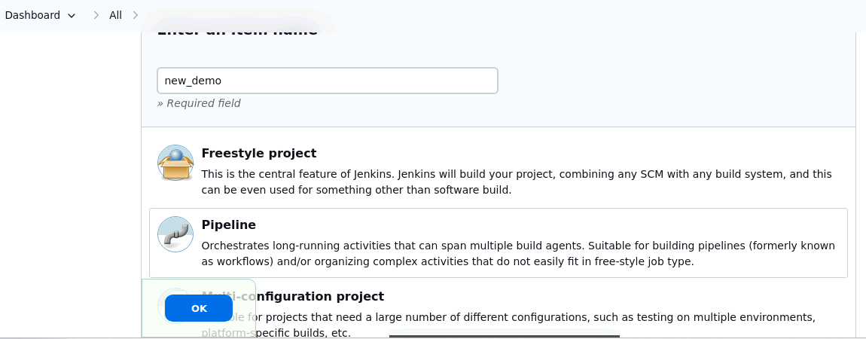

OUTPUT :-

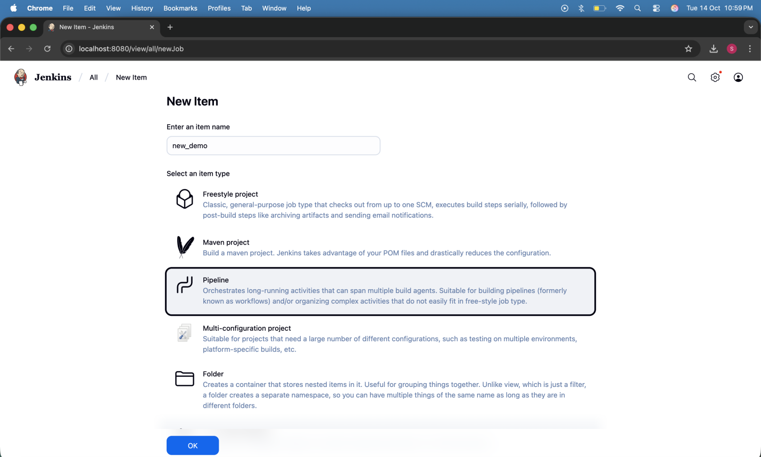

- Click on Pipeline as shown in the screenshot below:

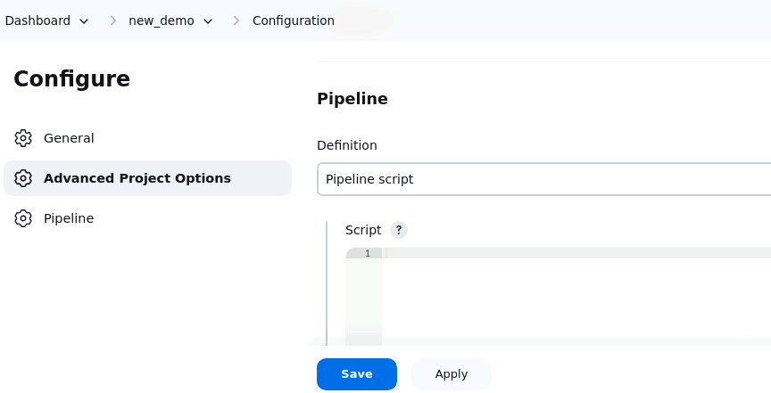

OUTPUT :-
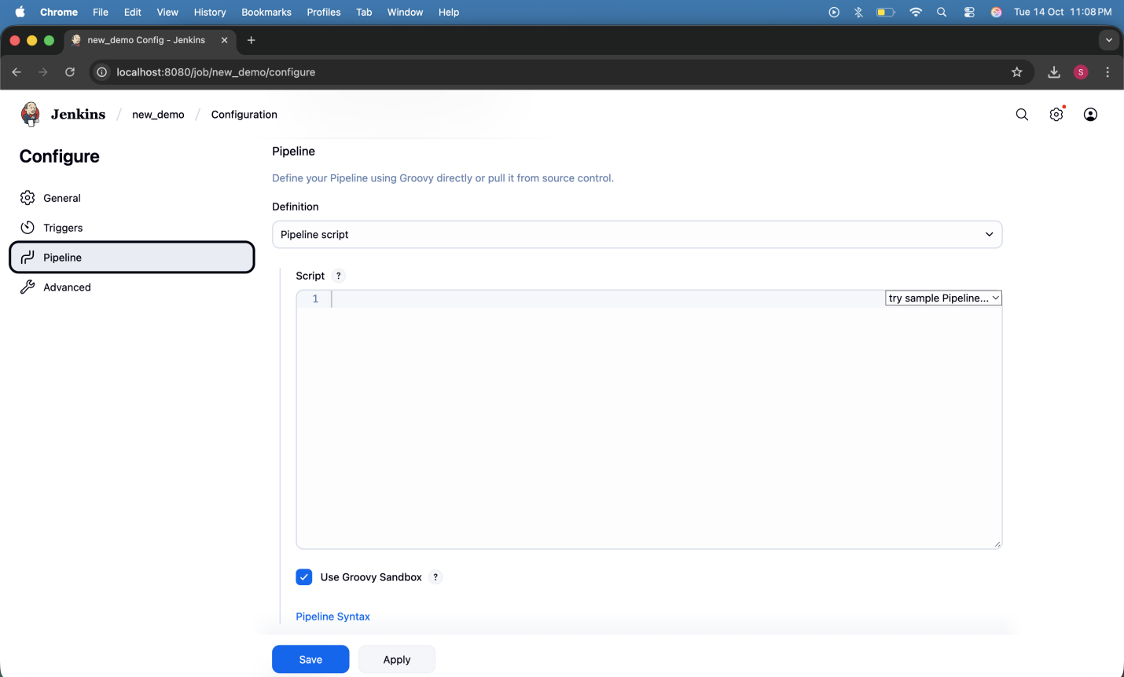
- Enter the following pipeline script in the script editor and click on Save as shown in the screenshot below:
pipeline {
agent any
stages {
stage("hello") {
steps{
echo"welcome to Jenkins pipeline"
}
}
}
}

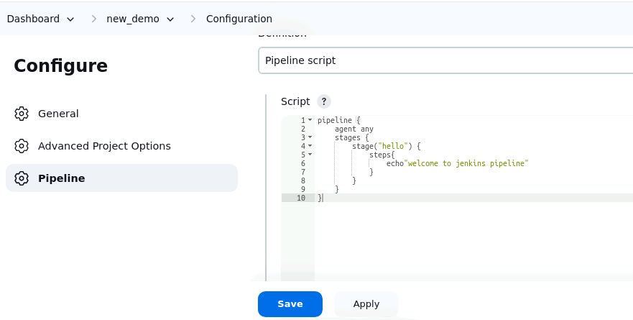

OUTPUT :-

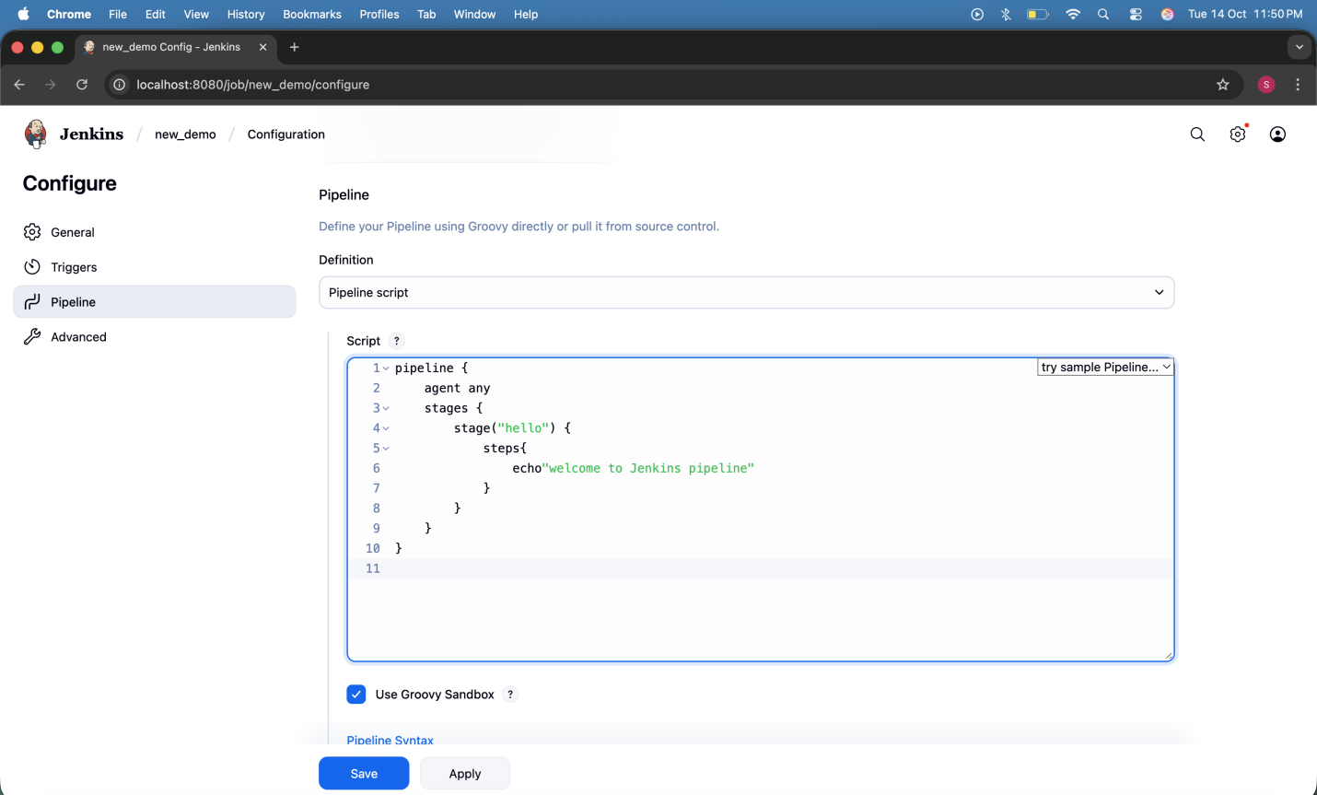
- Click on Build Now to run the pipeline script as shown in the screenshot below:

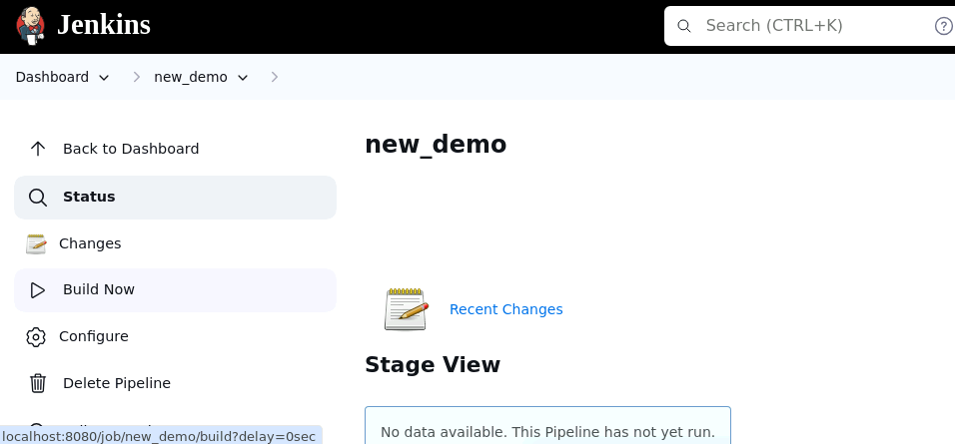

OUTPUT :-

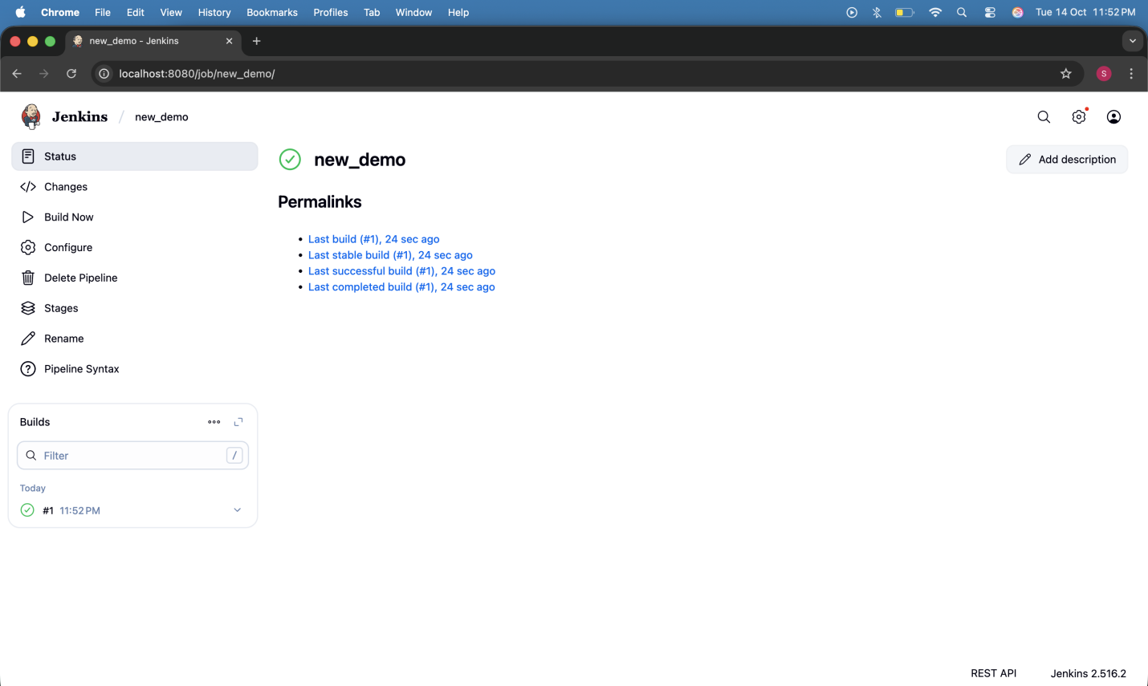
- Hover over the milliseconds number next to the build stage name as shown in the screenshot below:

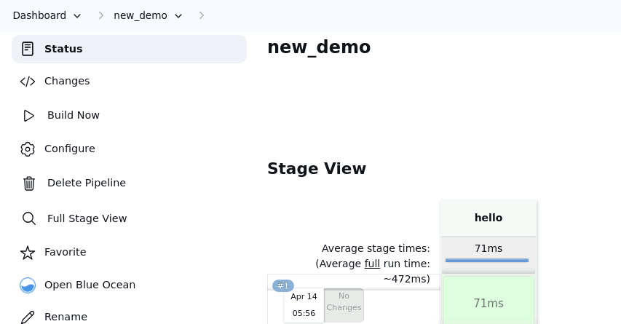

Note: Ensure that you hover the cursor over the milliseconds number without clicking on it

OUTPUT :-

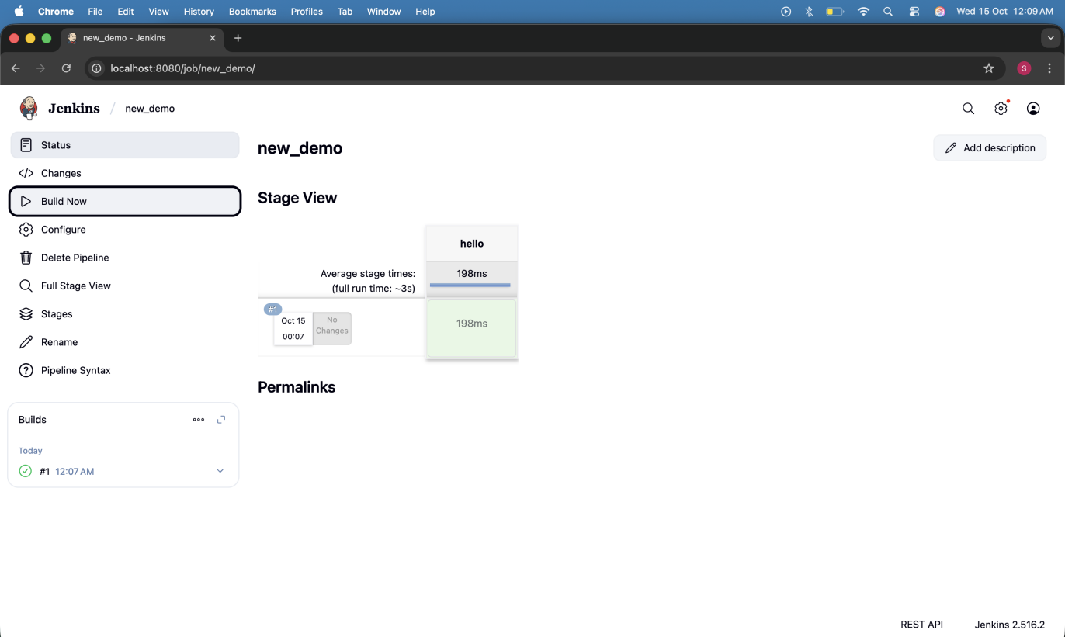

- Click on Logs as shown in the screenshot below:
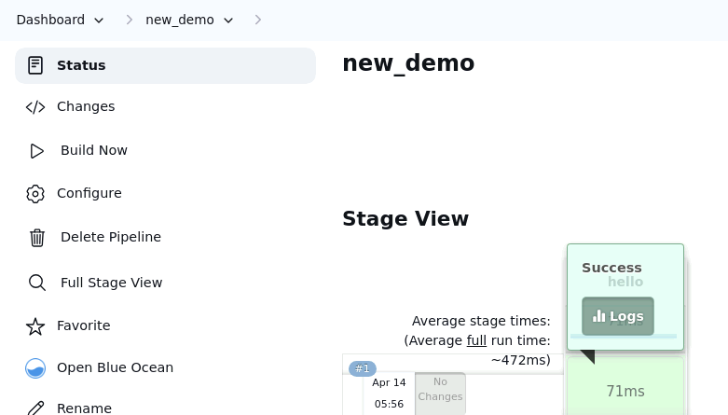

OUTPUT :-

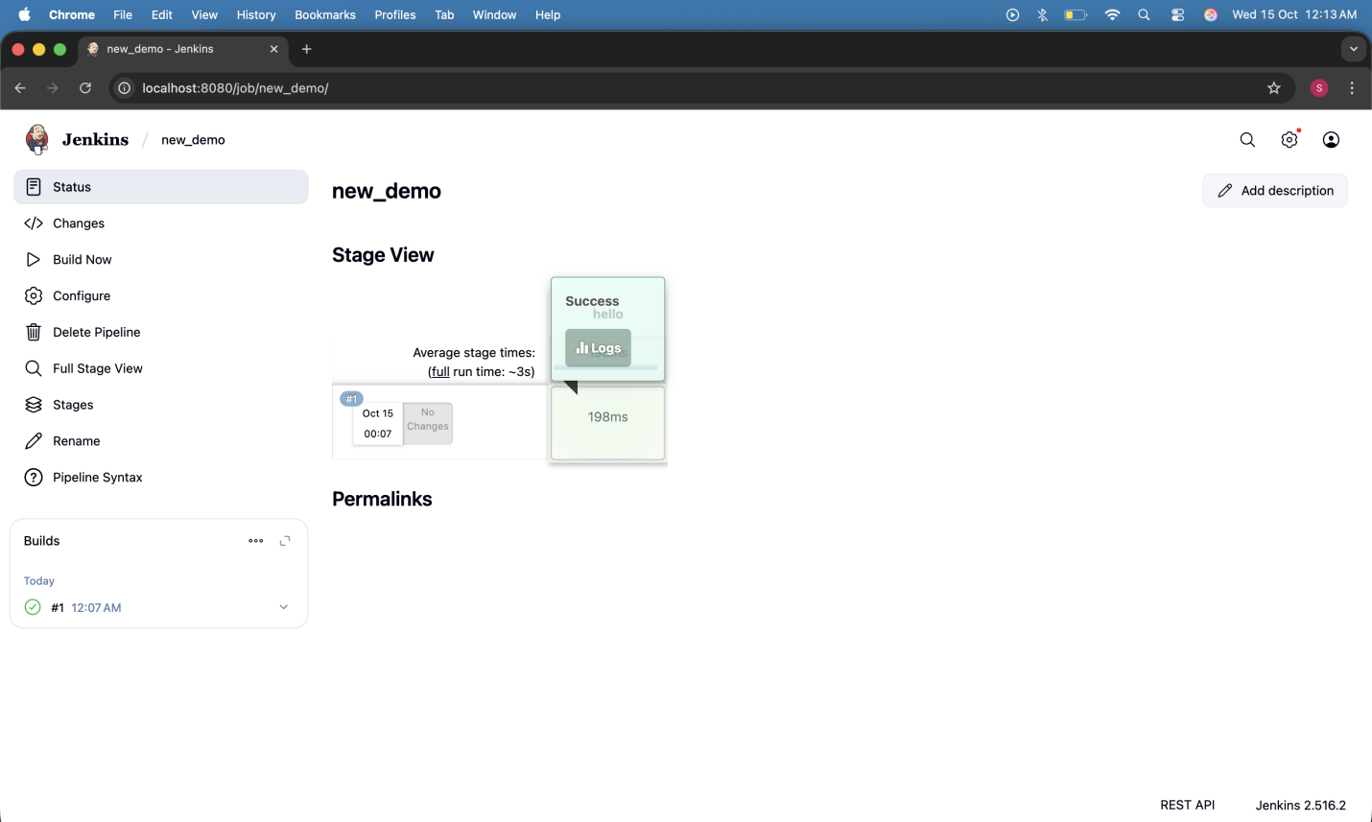
Check for the message in the top-left corner to confirm the successful execution of the pipeline stage as shown in the screenshot below:

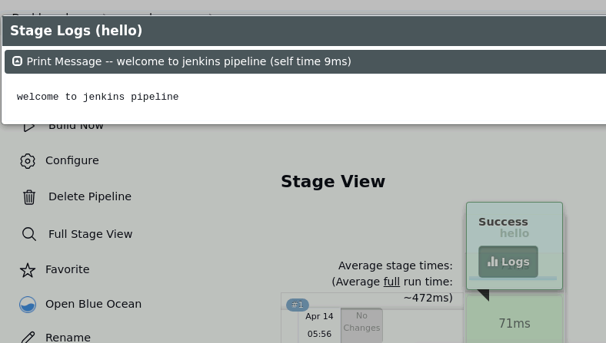

By following these steps, you have successfully created a pipeline script for automating build processes in Jenkins.

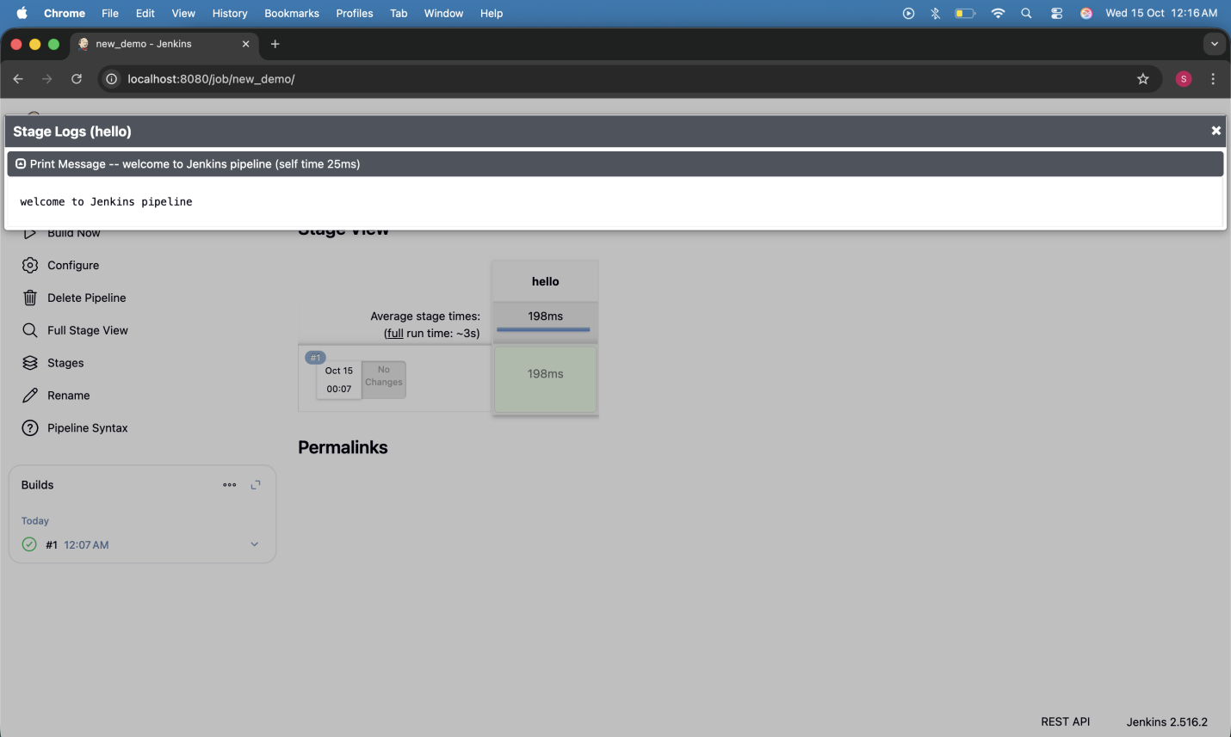
OUTPUT :-
Creating a pipeline for a project

1) Create a built using pipeline

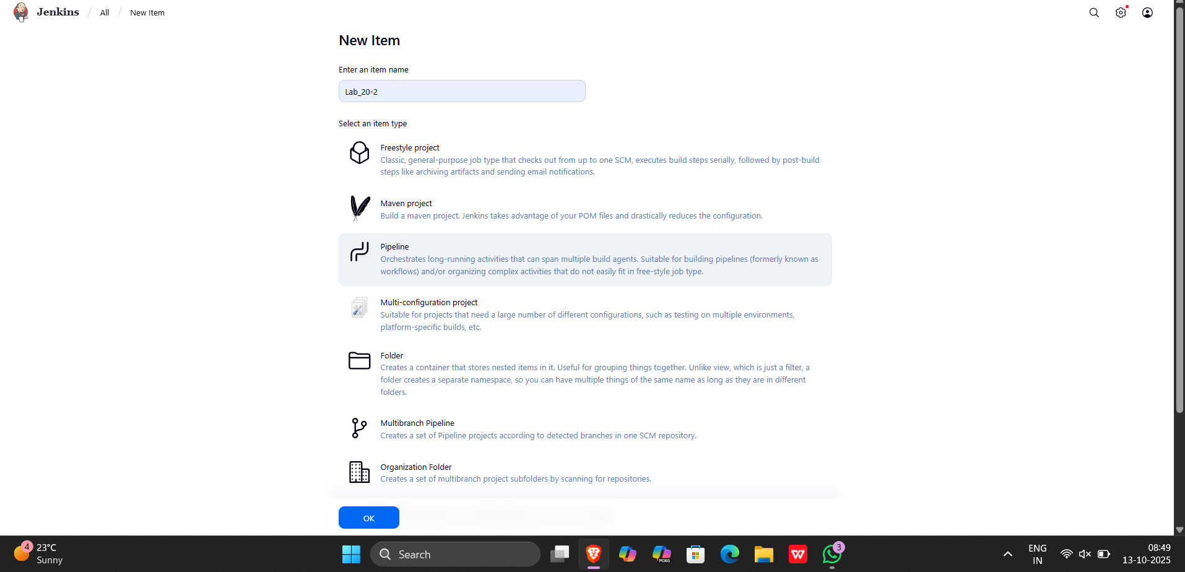

OUTPUT :-
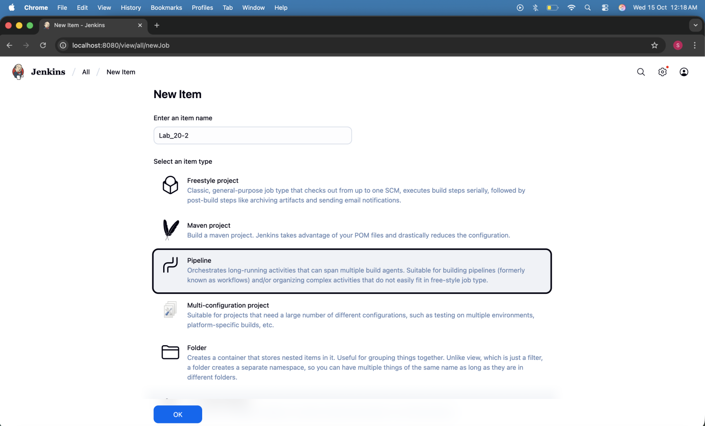

2) write the script for the pipeline in jenkinsfile in github

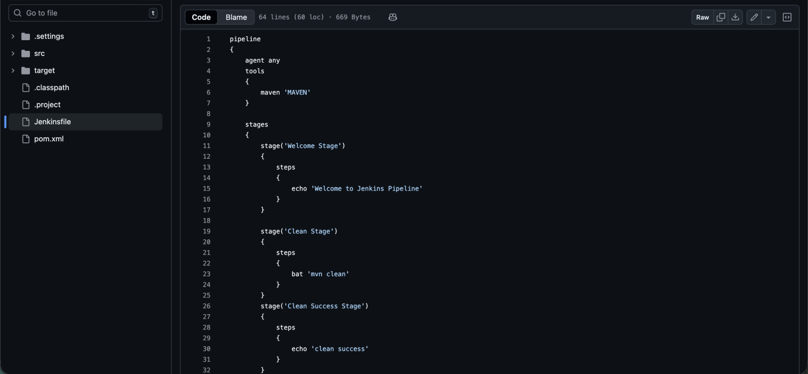

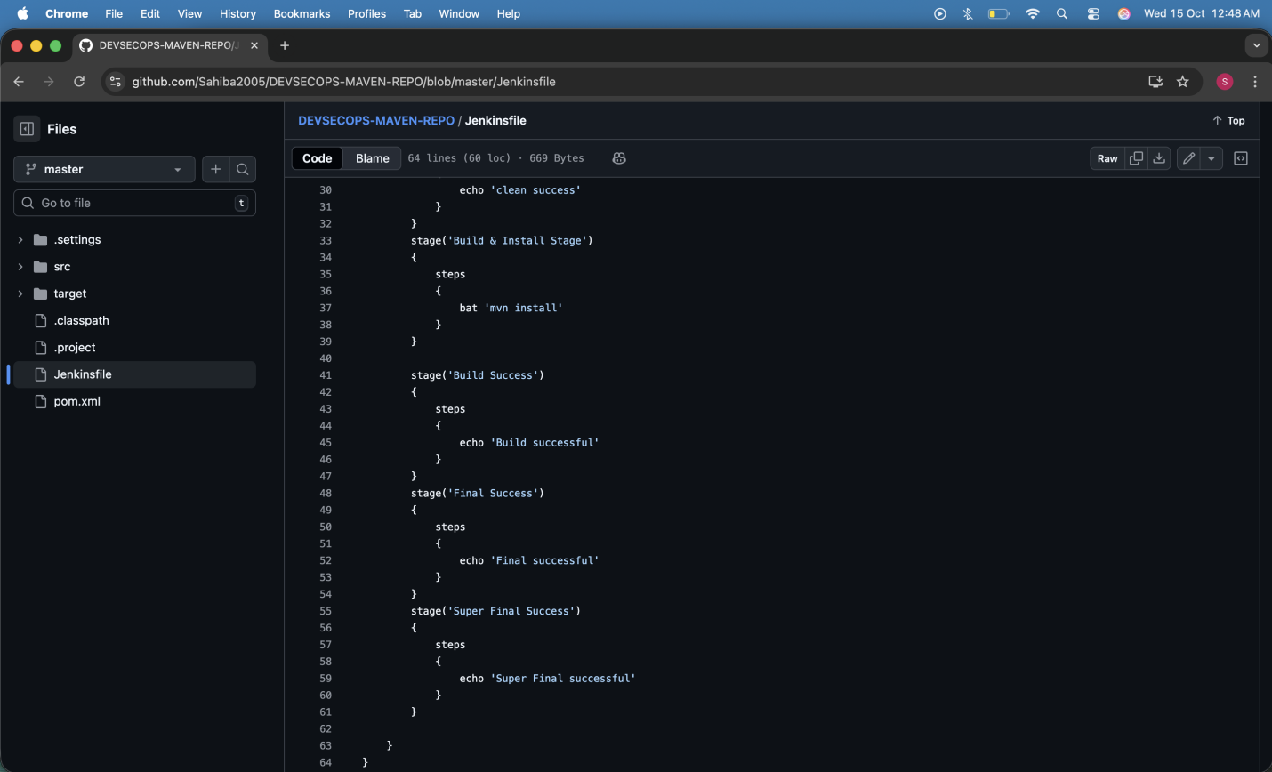

3) Add the repository url in github project and in pipeline

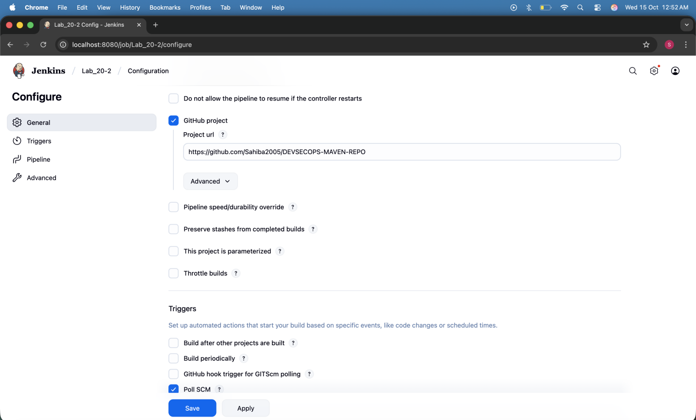
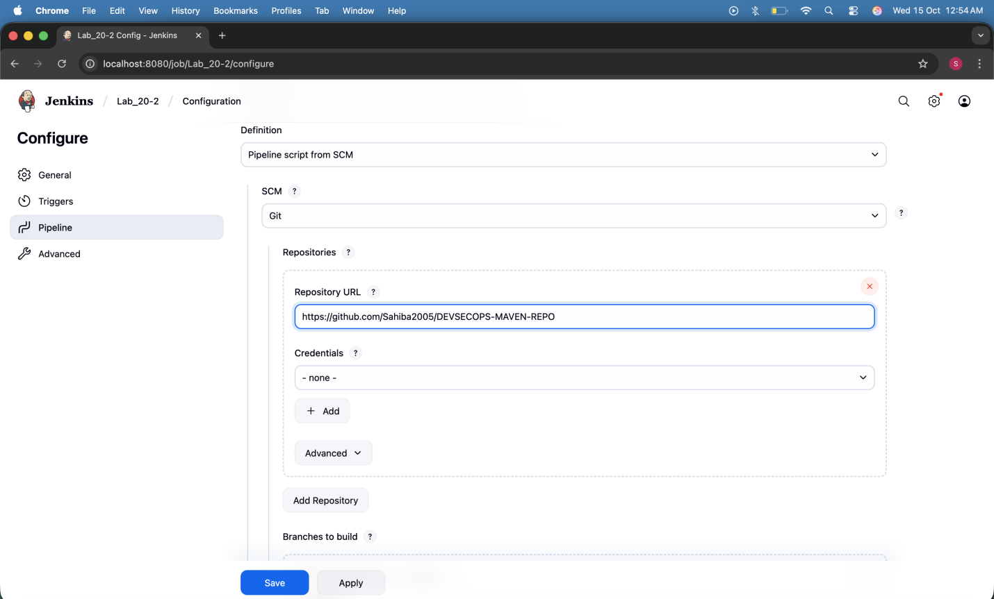

4) check poll scm option
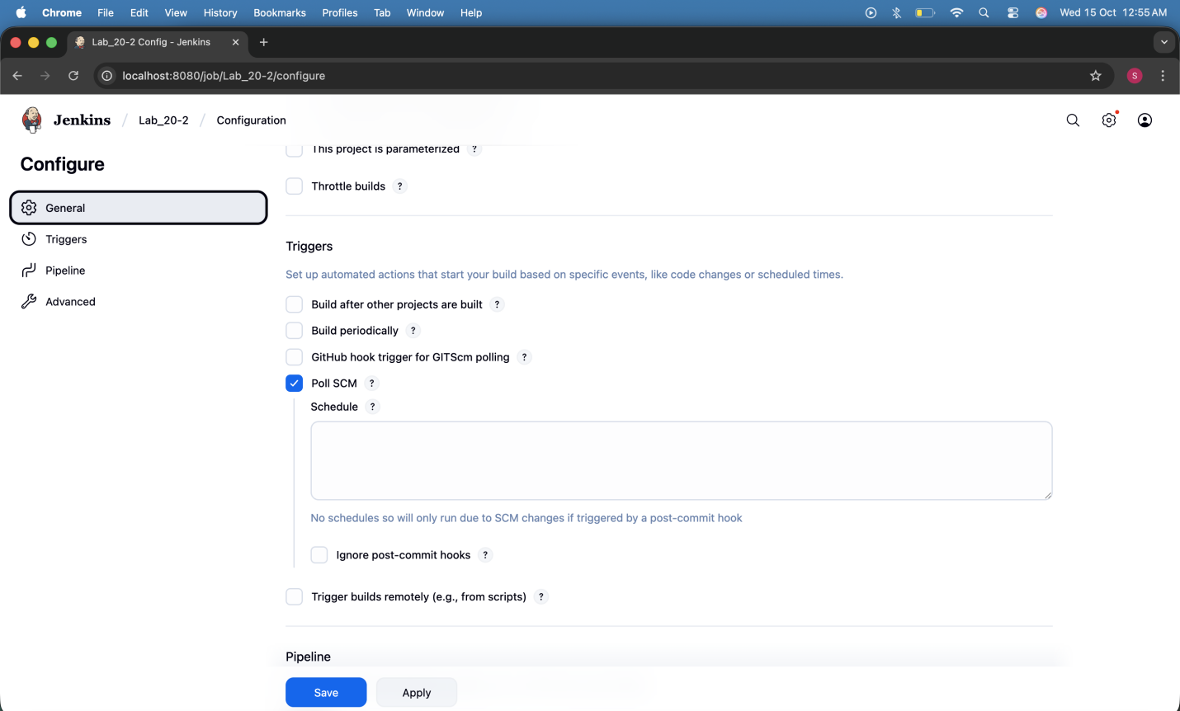

OUTPUT :-
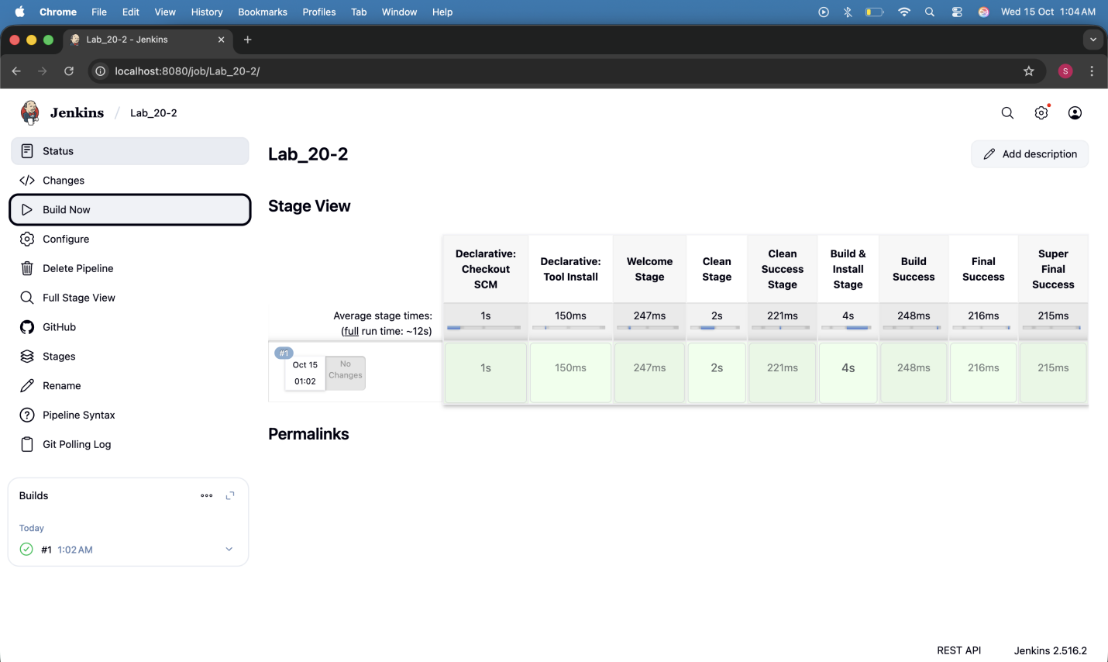
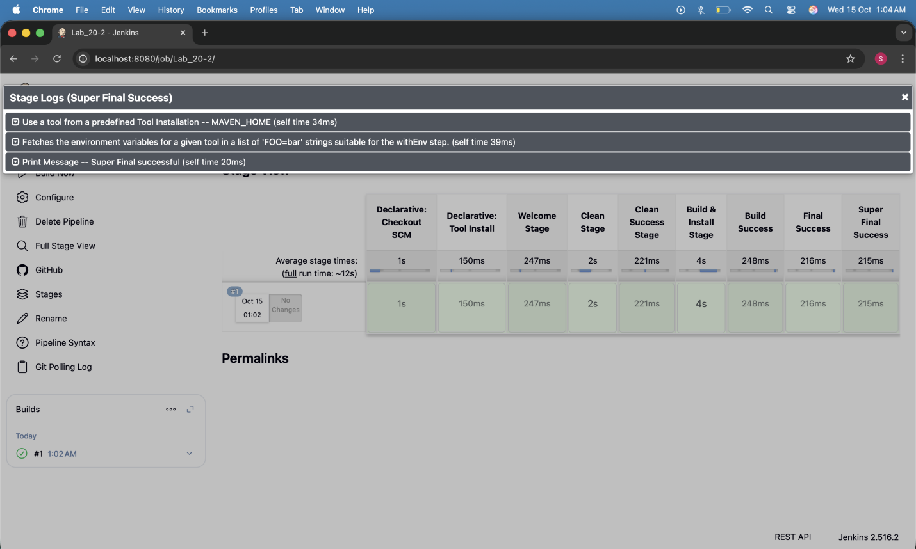

Pipeline script

pipeline
{
agent any
tools
{
maven 'Maven'
}

stages
{
stage('Welcome Stage')
{
steps
{
echo 'Welcome to Jenkins Pipeline'
}
}

stage('Clean Stage')
{
steps
{
sh 'mvn clean'
}
}
stage('Clean Success Stage')
{
steps
{
echo 'clean success'
}
}
stage('Build & Install Stage')
{
steps
{
Sh 'mvn install'
}
}

stage('Build Success')
{
steps
{
echo 'Build successful'
}
}
stage('Final Success')
{
steps
{
echo 'Final successful'
}
}

}
}

